

Year 10 Science
Physics 1 Test: Motion

SECTION 1: MULTIPLE CHOICE (1 mark each)
Circle your answer on the multiple choice answer sheet.

- Displacement is
- the same as distance travelled.
- the straight-line distance between two places.
- the straight-line distance and direction between two points.
- how fast something is travelling.

- Which of the following can NOT be used to measure the speed of a vehicle?
- a ticker timer
- a multiflash photograph
- a point to point camera
- an electronic trigger

- The reaction time for an average person who is alert and concentrating is
- 0.1-1.2 seconds
- 0.15-0.30 seconds
- 3.6 seconds
- 9.19 seconds

- Which of the following is least likely to cause distraction to a driver?
- speaking or texting on a mobile phone
- other people in the vehicle
- changing the radio station
- using indicators or changing gears

- A vehicle’s brakes work by
  - locking the wheels so the vehicle stops suddenly.
  - absorbing kinetic energy and converting it to heat energy by friction.
  - slowing the occupants of the vehicle down gradually to reduce impact.
  - putting your foot down pushes on the road more.

- A heavy vehicle is slower to accelerate and harder to stop than a light vehicle. This is because of
  - inertia.
  - velocity.
  - impact.
  - gravity.

The next three questions refer to the following diagram

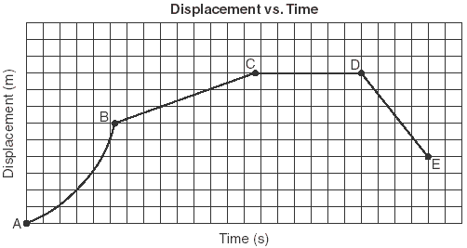

- The motion between A and B would be described as
  - constant speed
  - constant velocity
  - acceleration
  - deceleration

- The distance travelled between C and D is
a) 0 m
b) approximately 6
c) approximately 9 m
d) unable to be determined from this information

- From D to E the object would be
a) accelerating
b) decelerating
c) travelling forwards at constant velocity
d) travelling backwards at constant velocity

- Which of these is not an example of a force?
  - push
  - pull
  - twist
  - heat

- Which of the following is not an effect of a force?
- changing the speed of an object
- changing the direction of an object’s motion
- changing the size of an object
- changing the shape of an object

- Study the diagram below that shows the forces involved in an aeroplane.
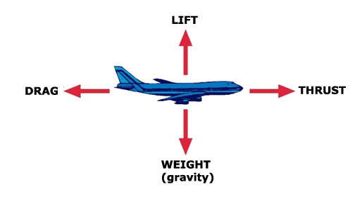
If the aeroplane is travelling forwards at constant velocity and at constant altitude (height) which statement is correct about the forces involved.
- The drag and the thrust are unbalanced.
- The weight and the lift are unbalanced.
- The drag and the thrust are balanced.
- All the forces are balanced.

- Which statement is correct about the forces shown in the diagram below?
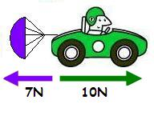
- The resultant force is 17N.
- The car will decelerate (slow down).
- The car will accelerate (speed up).
- The car will travel at constant speed.

- Which of the following is the best definition of energy?
- Energy is the ability to do work.
- Energy is something that changes the shape or motion of an object.
- Energy is something that can’t be created or destroyed.
- Energy is a measure of how much an object is affected by gravity.

- When energy moves from one place to another without changing its form, it is called an
- energy transport.
- energy transfer.
- energy transformation.
- energy transplant.
SECTION 2: WRITTEN
Write all answers in the spaces provided. Show working. If you need more space, ask for some lined paper

- A car was involved in a time trial. The car started from rest and accelerated as quickly as possible over the straight course of 500m. It took 25 seconds to complete this distance. Determine the average speed of the car during the time trial. (2)

- A parachutist is falling with a constant speed of 7 m/s. Calculate how long it will take to reach the ground 1200m below. (3)

- A toy truck is stationary, then rolls down a ramp with a constant acceleration of 0.2 m/s². Calculate its speed after 10 seconds. (3)

- A force of 9000 N is used to accelerate a car of mass 1000 kg along a smooth, flat road. Determine the acceleration of the car. (3)

- The efficiency of a car engine is about 20.6%. What does this mean? (2)

End of test (out of 28)

Formulae you might need:

F = m x a v = u +at

V_{av} = s Wt = m x g
t

a = v-u g = 9.8 m s⁻²
t

Ep= mxgxh Ek= ½ m v²

There are 1000 m in a km.
There are 3600 s in an hr.

ɳ= useful output x 100
input

Ep= mgh Ek= ½ mv²

Enrichment Section

- Indicate the direction and size of the resultant force for each of the following: (4)

a) 5N b) 40N c) 100N d) 2N
2N 2N
7N 50N 60N
3N

- A car, initially travelling at 15 ms⁻¹, accelerates at 2 ms⁻² for 4 seconds. Determine its final velocity. (3)

- A 750 kg boat was anchored in a stream. After the anchor was pulled up, it took 30 seconds for the boat to reach a velocity of 9km/hr.
- Convert the velocity to ms⁻¹. (2)
- Determine the acceleration of the boat. (3)
- Determine the force on the boat (2)

- Determine the velocity of an aeroplane of mass 1000kg which has a kinetic energy of 5000 kJ. (5)

- A roller coaster with mass 2000 kg falls from a height of 26 m. At the bottom of the fall, its velocity is 7 ms⁻¹. Determine the efficiency of the energy transfer from potential to kinetic.
(3)

